**DAILY ONLINE ACTIVITIES SUMMARY**

|  |  |  |  |  |  |  |  |  |
| --- | --- | --- | --- | --- | --- | --- | --- | --- |
| **Date:** | **30-05-2020** | | | | | **Name:** | **Sannidhi P** | |
| **Sem & Sec** | **8th sem B sec** | | | | | **USN:** | **4AL16CS084** | |
| **Online Test Summary** | | | | | | | | |
| **Subject** | | **-** | | | | | | |
| **Max. Marks** | | **-** | | **Score** | | | **-** | |
| **Certification Course Summary** | | | | | | | | |
| **Course** | **JAVASCRIPT Tutorial** | | | | | | | |
| **Certificate Provider** | | | **SOLOLEARN** | | **Duration** | | | **2hrs** |
| **Coding Challenges** | | | | | | | | |
| **Problem Statement- It was not given** | | | | | | | | |
| **Status: completed** | | | | | | | | |
| **Uploaded the report in Github** | | | | | **yes** | | | |
| **If yes Repository name** | | | | | **sannidhi1** | | | |
| **Uploaded the report in slack** | | | | | **yes** | | | |

Online Test Details: (Attach the snapshot and briefly write the report for the same)

Certification Course Details: (Attach the snapshot and briefly write the report for the same)

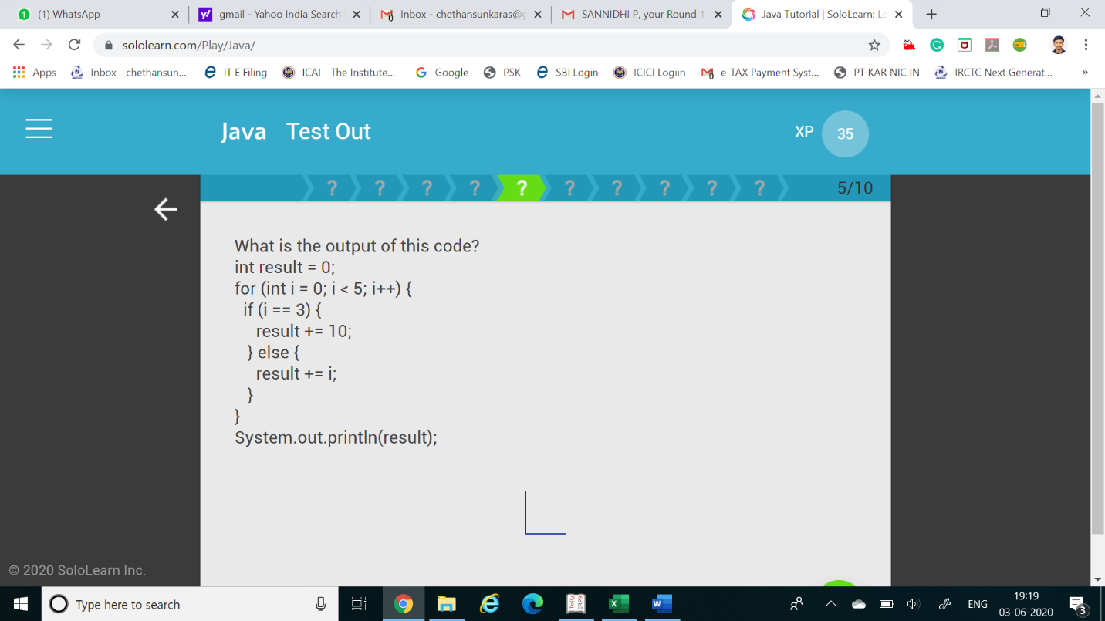Coding Challenges Details: (Attach the snapshot and briefly write the report for the same)

Coding was not given and it was uploaded for github and slack